For Office Use Only ADNR File No: _________________________ DATE STAMP:
ADF&G No: _________________________
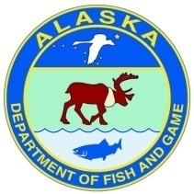
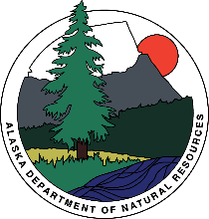

Alaska Aquatic Farm Program

Joint Agency Application – Part II

You are encouraged to submit a completed application as early in the filing period as possible. The current application form must be used and properly completed before state agencies can process your project. An incomplete application will not be processed. A checklist is included to assist you in meeting this requirement. The best way to facilitate the review of your application is to schedule a pre-application meeting with ADNR and ADF&G to discuss your project. The original application including attachments and all required fees must be delivered and present in the Alaska Department of Natural Resources office no later than April 30th.
The project location is in: ☐ Southeast Alaska ☐ Southcentral Alaska
☐ Kodiak ☐ Alaska Peninsula ☐ Other
This project is: ☐ First Time Application ☐ Renewal Application

A. APPLICANT INFORMATION
Click or tap here to enter text.
Name
Click or tap here to enter text.
Business Name (If Applicable)
Click or tap here to enter text.
Mailing Address (PO Box or Street Address)
Click or tap here to enter text.
City State Zip
Click or tap here to enter text.
Email Address
Click or tap here to enter text.
Home/Office Phone Cell Phone
Click or tap here to enter text.
Contact Name
Click or tap here to enter text.
Contact Phone Number
Click or tap here to enter text.
Business Partner Name (If applicable)
Click or tap here to enter text.
Business Partner Email Address (If applicable)
Click or tap here to enter text.
Business Partner Phone (If applicable)

B. PROJECT DESCRIPTION
In the space provided below, please provide a general description of your proposed aquatic farm site and operations. This should be a narrative of your proposal that includes where your project will be located, overall size including any hardening area, all species you intend to culture, type of farm gear, equipment, support facilities, and associated housing to be used including size, number, and construction materials. Your narrative should match the rest of the application information you provide. If additional space is necessary, please attach a separate document labeled “PROJECT DESCRIPTION”. Example information for project narrative can be found in Attachment I.
PROJECT DESCRIPTION
DATE SUBMITTED: Click or tap here to enter text.
Company Name
Click or tap here to enter text.

Site Location [Include water body, distance from nearest community, any landmarks, general region of Alaska, and whether on state tidal and/or submerged lands or private. Provide enough information to understand where it is located.]
Click or tap here to enter text.

Site Dimensions, Acres for Each Parcel
Click or tap here to enter text.

Total Acres of All Parcels
Click or tap here to enter text.

Species You Intend to Farm [Include scientific and common species name]
Click or tap here to enter text.

Culture Method [Describe operation activities to be done onsite such as outplanting of seedstock, husbandry techniques to be used (culling, sorting, washing, etc.), maintenance and monitoring activities, management of fouling organisms and incidental species, predator control measures, and schedule of activities such as timing of outplanting seeded lines or adding seedstock into trays, etc. Describe what methods you plan to use based on the definition in 5 AAC 41.400(6). "Culture" means to use or the use of methods to manipulate the biology and the physical habitat of a desired species to optimize survival, density, growth rates, uniformity of size, and use of the available habitat, and to efficiently produce a product suitable for a commercial market.]
Click or tap here to enter text.

Culture Gear and Equipment (Type, Size, Number, Configuration, Material, and Anchoring System) [If more than one parcel, indicate what parcel specific gear will be located on. If more than one species, indicate gear to be used for each. Gear includes any structure that holds or protects the organism like trays, tiers of lantern nets, Vexar bags, OysterGro system, grow-out submerged longlines, predator netting, longlines, buoys, depth control systems, etc. Include approximate installation schedule, or if and what gear will remain installed year-round etc.]
Click or tap here to enter text.

Seed Acquisition Plan (Commercially produced and/or wildstock) [Commercially produced juveniles or seed stock must be obtained from an approved seed source. Do you intend to collect wildstock juveniles or natural set organisms for direct culture on your proposed site? Yes/No. If yes, describe collection methods (applicable for indigenous species: i.e. mussels, scallops, abalone, natural set aquatic plants, etc. This does not refer to broodstock collection on behalf of hatcheries for propagation. If increasing number of acquisitions per year, indicate projected amounts per year. Aquatic plant species can be combined into total feet of line per year.]
Click or tap here to enter text.

Harvest Equipment and Method [Describe harvest equipment and methods to be used, activities to be done onsite, and schedule of harvest of aquatic farm product. If more than one species, include harvest information for each species or group of species like macroalgae if the harvest information is the same.]
Click or tap here to enter text.

Support Facilities (Type, Size, Number, Configuration, Material, and Anchoring) [Support facilities include caretaker facility, storage rafts, work rafts, processing rafts, etc.]
Click or tap here to enter text.

Access to and from Site [Include nearest community, transportation type used and how many times traversing back and forth]
Click or tap here to enter text.

Storage Location of Equipment and Gear When Not in Use [Include whether on private lands and nearest community]
Click or tap here to enter text.

C. PROJECT OPERATION PLAN
1. How will support facilities, culture gear and anchoring systems be maintained?
a. How often, in days per month, do you intend to monitor your site for things such as adequate anchoring, disease, exotic species settlement, fouling, gear drift, snow load, wind damage, vandalism, etc.?
Growing season (days/month) Off months (days/month)
b. How will you keep the gear and shellfish free of fouling organisms (hot-dip, air dry, pressure washing, etc.)?
Click or tap here to enter text.
c. How will you manage reduction of competing species over the course of operations (relocate sea stars, grow-out cages, or other possible protection from competing species)?
Click or tap here to enter text.
d. If you intend to use predator netting, how long will you keep netting over your product?
(months)
e. If using predator netting, how will you minimize impacts on non-target species, including seabirds, seals, sealions, walrus and whales?
Click or tap here to enter text.
2. Projected Harvest Rotation Consistent with Life History
a. How often do you intend to harvest your product by species?
Click or tap here to enter text.
b. Do you plan on utilizing density manipulation by culling or redistribution?
Click or tap here to enter text.
c. What techniques will be used to optimize growth or condition of product?
Click or tap here to enter text.
3. Acquisition of hatchery or wild seed
a. Will you use a certified or approved shellfish seed source(s)? Yes ☐ No ☐
b. Will you use an Alaska kelp hatchery? Yes ☐ No ☐
c. How do you intend to collect wild seed? (Applicable for indigenous species: i.e. clams, natural set kelp, invertebrates, etc.)
Click or tap here to enter text.
4. Describe how operation of the aquatic farm will improve the productivity of species intended for culture not covered by the previous questions (examples: predator exclusion, reduction of competing species, density manipulation by culling/redistribution, importing natural or hatchery seed, program harvest to optimize growth/condition and habitat improvement)?
Click or tap here to enter text.

D. PROJECT LOCATION
1. Coordinates
Please provide latitude and longitude coordinates for each corner of each parcel at the proposed farm site. Identify each parcel to be used. For example, Parcel 1 - growing area, Parcel 2 - hardening area, etc. Latitude and longitude coordinates must be in NAD83 datum using degrees and decimal minutes format to the nearest .001 minute (Example: Longitude -133° 17.345), obtained using a Global Positioning System (GPS). If you are applying for more than three parcels or your proposed parcels have other than four corners, please provide those coordinates in your project description or on a separate sheet.

Parcel 1: |  | NE Corner | No. 1: Latitude |  |  | Longitude
 |  | SE Corner | No. 2: Latitude |  |  | Longitude
(e.g. Grow-out Area) |  | SW Corner | No. 3: Latitude |  |  | Longitude
 |  | NW Corner | No. 4: Latitude |  |  | Longitude
Parcel 2: |  | NE Corner | No. 1: Latitude |  |  | Longitude
 |  | SE Corner | No. 2: Latitude |  |  | Longitude
(e.g. Hardening Area) |  | SW Corner | No. 3: Latitude |  |  | Longitude
 |  | NW Corner | No. 4: Latitude |  |  | Longitude
Parcel 3: |  | NE Corner | No. 1: Latitude |  |  | Longitude
 |  | SE Corner | No. 2: Latitude |  |  | Longitude
(e.g. Support Facility Area) |  | SW Corner | No. 3: Latitude |  |  | Longitude
 |  | NW Corner | No. 4: Latitude |  |  | Longitude

2. Site Size
Please use the following formula to compute area. For more complex parcel shapes, you may wish to use the Measure Area tool in Alaska Mapper found at https://mapper.dnr.alaska.gov/. If you are applying for more than three parcels or your parcels are not rectangular, you may provide this information in the project description or on a separate sheet.
- To compute the total area (sq. ft), multiply the width (ft) by the length (ft) of Parcel 1. The outside length and width of the Parcel must include your anchors and anchoring system plus any scope.
- Divide the area (sq. ft) of Parcel 1 by 43,560, to convert the area from sq. ft to acres.
- Repeat for each separate Parcel of your proposed farm site.
- Add the acreage of each Parcel to get the total tideland acreage for your proposed farm site.
- Write the Total Acreage on the line where indicated.
- Note that the number of acres must correspond to your farm site maps and drawings.
Parcel 1: |  | feet (x) |  | feet (=) |  | square feet (÷) 43,560 =
 | (Width of Parcel 1) |  | (Length of Parcel 1) |  | (Area) |  | (Acres)
Parcel 2: |  | feet (x) |  | feet (=) |  | square feet (÷) 43,560 =
 | (Width of Parcel 2) |  | (Length of Parcel 2) |  | (Area) |  | (Acres)
Parcel 3: |  | feet (x) |  | feet (=) |  | square feet (÷) 43,560 =
 | (Width of Parcel 3) |  | (Length of Parcel 3) |  | (Area) |  | (Acres)

How many total acres of state-owned tidelands are you applying for (add all parcel acres):
(Total Acreage)
If you are also applying for state owned uplands for support facilities, how many total upland acres?
(Total Upland Acreage)
3. Maps and Diagrams
Provide copies of maps and diagrams including general and detailed location maps, site plan map (an overview), cross-sectional diagram and detailed drawings. If the project has multiple parcels, you must provide maps of each parcel. Copies of the maps and drawings should be no larger than 8½” x 11” (standard letter size). Examples are provided at the end of the application.
A list of mapping resources is provided below:
Alaska Mapper https://mapper.dnr.alaska.gov/
Alaska Ocean Observing System Mariculture Map https://mariculture.portal.aoos.org/
NOAA Nautical Charts www.charts.noaa.gov
ShoreZone Mapping System https://www.fisheries.noaa.gov/alaska/habitat-conservation/alaska-shorezone
Catalog of Anadromous Streams https://www.adfg.alaska.gov/sf/sarr/awc/
*Be sure to include a legend box on all maps and diagrams you provide with your application with the following information:
FORMATTING |  | LEGEND BOX EXAMPLE
Figure No. and Title  Applicant Name (Business Name)  Waterbody  Area/Region  Today’s Date |  | Figure 1 Detailed Location Map  Alaska’s Best Oysters  Jerryton Bay  East of Prince of Wales Island, Southeast AK  March 30, 2012

- General Location Map - This map is a larger scaled map showing larger surrounding area with less detail (See Attachment 2, Figure 1). Use a USGS Topographic quadrangle map (scale: 1" = one mile (1:63,360)) and label it “Figure 1” and show the following information:
☐ USGS Map Name (e.g. Craig B-4)
☐ General location of the farm site
☐ Distance (in nautical miles), and direction (arrow) of the site from the nearest community
☐ A directional arrow identifying North
☐ Scale
☐ Legend box (example on previous page)
- Detailed Location Map - This map is a smaller scaled map showing more detail (See Attachment 2, Figure 2). Use a National Oceanic and Atmospheric Administration (NOAA) navigational chart and label it “Figure 2” and show the following information:
☐ NOAA Chart No.
☐ Boundaries of each farm area parcel and clearly label all corners (NE, SE, SW, and NW)
☐ Directional arrow identifying North
☐ Scale on map
☐ Legend box (example on previous page)
If uplands area is proposed:
☐ Location and type of use (e.g. housing, storage shed, etc.)
- Site Plan Map - Draw an overhead view of the farm area parcel(s) and surrounding area (See Attachment 2, Figures 3 and 4). Label it “Figure 3” and show the following information:
☐ All in-water structures and anchoring systems (All anchoring systems and anchor scope have to be inside the farm parcel boundary)
☐ All equipment and support facilities with dimensions (in feet)
☐ Areas of eelgrass beds (intertidal zone)
☐ Areas of kelp beds (subtidal zone)
☐ Fuel and chemical storage
☐ Nearby anadromous streams (fish)
☐ Distance between all facilities, gear or equipment on the proposed farm site
☐ Legend box (example on previous page)
- Cross-Sectional Diagram(s) - Provide Cross-Sectional Diagram(s) of all support facilities, equipment, and gear showing their placement and anchoring systems (See Attachment 2, Figure 5). Note that more than one diagram may be required. Label it “Figure 5” (and so on) and show the following information:
☐ Distance from bottom of gear to ocean bottom at mean lower low tide
If suspended or on-bottom culture:
☐ water depth at low tide
☐ major on-bottom physical features (sand, mud, silt, clay, bedrock, cobble, shells, rockweed, algae/seaweed) and contours
☐ Dimensions of the anchoring configuration and poundage
☐ Scale
☐ Legend box (example on previous page)
- Detailed Drawing(s) - Provide Detailed Drawing(s) of all support facilities, equipment, and gear (See Attachment 2, Figure 5). Note that more than one diagram may be required. Label and show the following information:
☐ Draw and label the dimensions (length/width/height) of all proposed gear and equipment
☐ Legend box (example on previous page)

E. SITE SUITABILITY – PHYSICAL AND BIOLOGICAL CHARACTERISTICS
1. Is the proposed location protected from severe storms, strong currents, winter ice, etc. and if not, is the farm designed for extremes?
Yes ☐ No ☐ Additional Information:
Click or tap here to enter text.
2. Does your site have suitable water exchange for species of culture? Yes ☐ No ☐
3. Are water temperatures suitable for proposed species of culture? Yes ☐ No ☐
(Note: temperatures > 60° and < 31° F may pose problems such as Vibrio bacteria contamination or icing.)
4. Is there any significant freshwater influence near the farm? Yes ☐ No ☐
(Note: freshwater may impact shellfish growth and/or survival or carry fecal coliform or other pollutants)
5. Is the salinity concentration at your proposed farm site appropriate for species of culture? Yes ☐ No ☐
6. Have you monitored the phytoplankton (microalgae) abundance and types during the main grow-out season?
Yes ☐ No ☐ If yes, findings:
Click or tap here to enter text.
(Note: shellfish depend on phytoplankton for food, but harmful phytoplankton can prevent harvest/sales.)
7. Have you monitored suspended sediments or turbidity (e.g. water clarity/transparency using a secchi disc) at
your proposed farm site? Yes ☐ No ☐ If yes, findings:
Click or tap here to enter text.
(Note: This is used as rough check for microalgae densities, run-off, and glacial silt (milky- grey color).)
8. For on-bottom culture, are the bottom characteristics suitable for the proposed species? Yes ☐ No ☐
Substrate and vegetation?
Click or tap here to enter text.
9. For on-bottom culture, how will bottom characteristics be made suitable if not already?
Click or tap here to enter text.
10. For suspended culture, is the water depth sufficient to prevent gear from grounding and impacting the benthos
under floating structures? Depth of Gear (in ft): Water depth at low tide (in ft):
11. Is your proposed site more than 300 ft from an anadromous fish stream? Yes ☐ No ☐
12. Are you aware of any eelgrass or kelp beds on or near your proposed farm site? Yes ☐ No ☐ If yes, describe:
Click or tap here to enter text.
13. For farming using on-bottom culture methods, is there insignificant wild stock of the species to be cultured on the proposed farm site? (Reference 5 AAC 41.235) Yes ☐ No ☐ Additional information
Click or tap here to enter text.
14. Are there existing uses near your proposed farm site such as boat traffic, existing fisheries or a sensitive area as listed in section C of Part 1, etc. that may be impacted by the farm operation? Yes ☐ No ☐ If yes, describe how your farm can be sited to mitigate conflicting uses?
Click or tap here to enter text.

F. KNOWN EXISTING USES
Please check the boxes below, to indicate existing human and/or wildlife uses observed or known to exist at or within one mile of the proposed farm site. Indicate the locations of these existing uses on the Site Plan Map if specific locations are known (refer to page 8, Section 3c).
☐ mining
☐ timber harvest or transfer
☐ residential use
☐ harbor development
☐ sheltered boat anchorage
☐ seaplane landing
☐ commercial lodges
☐ sightseeing
☐ recreation
☐ tourism
☐ historical/cultural/archaeological site
☐ other aquatic farm projects
☐ commercial fishing
☐ sport fishing
☐ salmon hatcheries
☐ hunting
☐ seafood processing plant
☐ upland access route(s) areas, bear trails, etc.
☐ wildlife use, (e.g. shorebirds, sea mammal haul-outs)

☐ subsistence; list species and frequency:
Click or tap here to enter text.
☐ navigational channels:
Click or tap here to enter text.
☐ other; list:
Click or tap here to enter text.
G. SUPPORT FACILITIES
1. Personnel/Caretaker Housing (additional annual fees apply)
Are you proposing any personnel/caretaker housing? Yes ☐ No ☐
If yes, the proposed size will be: (Width) (Length) (Height)
Please attach diagrams/drawings with labels clearly showing the Personnel/Caretaker housing.
Note: you may stay a maximum of 14 consecutive days at your site on state-owned uplands or tidelands without applying for personnel/caretaker housing.
2. Enclosed Processing Facility
Are you proposing any enclosed processing facility? Yes ☐ No ☐
If yes, the proposed size will be: (Width) (Length) (Height)
Please be sure the processing facilities are included in the maps and diagrams described in the Maps and Diagrams section above.
3. Upland Property
Do you currently own or lease upland property adjacent to, or near, the proposed farm site that you plan to use in conjunction with your proposal? Yes ☐ No ☐ If yes, attach a copy of ownership deed or lease.
If you are the adjacent upland owner, are you applying for a preference right under 11 AAC 63.040(f)?
Yes ☐ No ☐

H. CITY AND BOROUGH CONTACTS
1. City/Borough Authorization
If you are applying within a city or borough, please contact the appropriate authority as additional authorizations may be required from them. Please provide the name, address, and telephone number of the person(s) you contacted and list any required authorizations.
CITY/BOROUGH PHONE CONTACTED?
☐ City of Cordova 907-424-6220 Yes ☐ No ☐
☐ City of Klawock 907-755-2261 Yes ☐ No ☐
☐ City and Borough of Wrangel 907-874-2381 Yes ☐ No ☐
☐ City of Craig – Planning & Zoning 907-826-3275 Yes ☐ No ☐
☐ City and Borough of Juneau – Permit Center 907-586-5252 Yes ☐ No ☐
☐ City and Borough of Sitka – Planning & Community Development 907-747-1814 Yes ☐ No ☐
☐ City of Thorne Bay 907-828-3380 Yes ☐ No ☐
☐ City and Borough of Yakutat – Planning & Zoning Commission 907-784-3323 Yes ☐ No ☐
☐ Kenai Peninsula Borough – Land Management Division 907-714-2205 Yes ☐ No ☐
☐ Kodiak Island Borough – Community Development 907-486-9363 Yes ☐ No ☐
☐ Lake and Peninsula Borough – Community Development 907-246-3421 Yes ☐ No ☐
☐ Aleutians East Borough – Permitting 907-383-2699 Yes ☐ No ☐
☐ Ketchikan Gateway Borough – Planning & Community Development 907-228-6610 Yes ☐ No ☐
☐ Haines Borough 907-766-6401 Yes ☐ No ☐
Type of Authorization required by City or Borough: Click or tap here to enter text.

I. WATER QUALITY INFORMATION – Department of Environmental Conservation
1. Do you plan to use a boat on your farm site? Yes ☐ No ☐ If yes, indicate the type of marine sanitation
device.
Click or tap here to enter text.
- If you plan to have personnel housing or caretaker facilities:
Will wastewater be discharged from these facilities? Yes ☐ No ☐ If yes, what are the daily maximum and
average discharge volumes? Maximum Average
- Were there any sources of past pollution at the site, such as a shore-based seafood processor, log transfer facility, industrial facility, oil spill contamination, or town or village? Yes ☐ No ☐ Unknown ☐
If yes, identify:
- The type of previous use (e.g. mine, village, seafood processor, oil spill).
Click or tap here to enter text.
- The last known date of use.
- The distance from site previously used to your proposed site.
Click or tap here to enter text.

- Are you aware of any current potential sources of human or industrial pollution in the area? (e.g. sewage outfalls, oil contamination, industrial transfer facilities upland operations, boar harbors, etc.)
Yes ☐ No ☐ If yes, describe:
- The type of discharge(s).
Click or tap here to enter text.
- The location and distance from your site.
Click or tap here to enter text.
- The name of the discharger(s), if known.
Click or tap here to enter text.
- Are you aware of any other planned development in the general area of your proposed site?
Yes ☐ No ☐ If yes, describe the planned development.
Click or tap here to enter text.
- ADEC may request that you provide a map for certain projects to show the following information:
  - areas of wastewater disposal systems, including both sewage and grey water discharge points (grey water means domestic wastewater from laundry, kitchen, etc., which does not contain human waste)
  - location of drinking water, including drinking water wells or other drinking water system sources (fresh water and salt water), within 200 feet of any proposed or existing wastewater disposal systems
  - location of solid waste storage and disposal sites (Note: you are encouraged to use existing permitted sites for the disposal of solid wastes. If there are not any existing permitted disposal sites in the area and they are necessary in your operation, you must contact the ADEC for authorization)
  - areas used for fuel and chemical storage

J. APPLICATION SIGNATURE BLOCK
AQUATIC FARM APPLICATION SIGNATURE AND
PROGRAM CERTIFICATION STATEMENT
The information contained in this aquatic farm application is true and complete to the best of my knowledge and I certify that the proposed activity complies with and will be conducted in a manner consistent with all State and Federal Agency policies and regulations. I understand that modifications to the proposed activity may require additional review and that I may need to apply for additional authorizations.
This certification statement does not provide authorization necessary to sell my product. I understand I must separately apply for and hold a Growing Area Certification and a Shellfish Harvester or Shellfish Dealer Permit from the Department of Environmental Conservation.
Printed Name | Click or tap here to enter text.
Signature of Applicant |  | Date | Click or tap to enter a date.
Printed Name | Click or tap here to enter text.
Signature of Applicant |  | Date | Click or tap to enter a date.
☐ I have enclosed the application fee required under 11 AAC 05.230(d)(3)(A)
In submitting this form, the applicant certifies that he or she has not changed the original text of the form or any attached documents provided by the Division. This information is made a part of the state public land records and becomes public information under AS 40.25.110 and 40.25.120 (unless the information qualifies for confidentiality under AS 38.05.035(a)(8) and confidentiality is requested, AS 43.05.230, or AS 45.48). Public information is open to inspection by you or any member of the public. A person who is the subject of the information may challenge its accuracy or completeness under AS 44.99.310, by giving a written description of the challenged information, the changes needed to correct it, and a name and address where the person can be reached. False statements made in an application for a benefit are punishable under AS 11.56.210. In submitting this form, the applicant agrees with the Department to use “electronic” means to conduct “transactions” (as those terms are used in the Uniform Electronic Transactions Act, AS 09.80.010 - AS 09.80.195) that relate to this form and that the Department need not retain the original paper form of this record: the department may retain this record as an electronic record and destroy the original.

Attachment 1
Example Project Description

SAMPLE INFORMATION TO INCLUDE IN PROJECT DESCRIPTION OUTLINE
The proposed aquatic farm site is composed of four separate parcels located on state-owned tidal and submerged lands, totaling about 6.82 acres. Parcels include:
- growing area measuring 292 ft x 546 ft (3.66 acres) for subtidal suspended culture of Pacific oysters using grow-out raft and cage system (Parcel 1);
- intertidal area measuring 60 ft x 154 ft (0.21 acre) for hardening and defouling (Parcel 2);
- support facility area measuring 46 ft x 190 ft (0.20 acre) for a dock and storage (Parcel 3);
- Seasonal growing area measuring 200 ft x 600 ft (2.75 acres) for submerged growing lines for culture of ribbon and sugar kelp (Parcel 4).
The proposed aquatic farm is located about 24.7 nautical miles south-southwest of Wrangell near Rocky Bay, a small bay near the mouth of Mosman Inlet on Etolin Island in southeastern Alaska. (Attachments 1-5)
Parcel 1 will hold eight (8) – 16 ft by 20 ft oyster grow-out rafts. Each grow-out raft will use 100 to a maximum of 300 Aquamesh cages stacked 10-high. Each cage will measure 22 inches wide x 22 inches long x 6 inches deep, manufactured of 1- inch by 1-inch PVC coated wire mesh. The 6 ft stacks of cages would hang 8 ft under the water’s surface. In addition, in the southwestern portion of the parcel, a 40 ft x 40 ft processing float with one 16 ft x 16 ft work shed, a covered area, and two 20 ft x 4 ft work platforms on each side will be used to accommodate oyster grow-out rafts during processing. The anchor system for all rafts would consist of floating anchor lines from each corner secured using 300 lb concrete anchors in water 60 ft deep. All rafts are constructed of untreated local wood with floatation made of closed cell (extruded) expanded polystyrene (Attachments 6 – 10).
Parcel 2 will be used for hardening and defouling of Pacific oysters, using Aquamesh trays measuring 22 inches wide by 22 inches long by 6 inches deep (Attachment 11).
Parcel 3 will be for support facilities. A dock measuring 20 ft x 30 ft will be anchored on this parcel for storage of gear. Two 100-pound Danforth anchors and chain will be installed on year 2 and remain year-round. (Attachment 12)
Parcel 4 will contain 20 – 400 ft longlines for culture of aquatic plants. Submerged longlines will be installed seasonally in October. Each line will be suspended 7 feet below the surface with depth-control systems with dropper weights and buoys. Harvest will occur in May and all culture gear removed. Anchors and mooring buoys will remain onsite year-round.
Upland facilities and support structures are located on National Forest Service lands adjacent to the farm site. Access to the site is by skiff from the adjacent uplands. Equipment and gear storage will be located on the permitted uplands or in Ketchikan.

Attachment 2
Figure 1
Example General Location Map

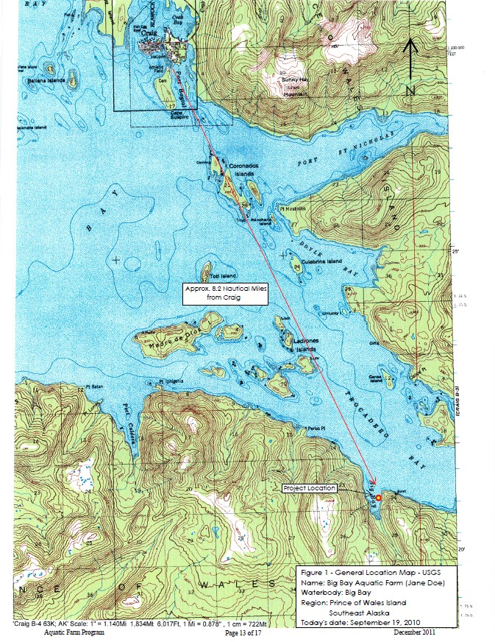

Attachment 2
Figure 2
Example Detailed Location Map
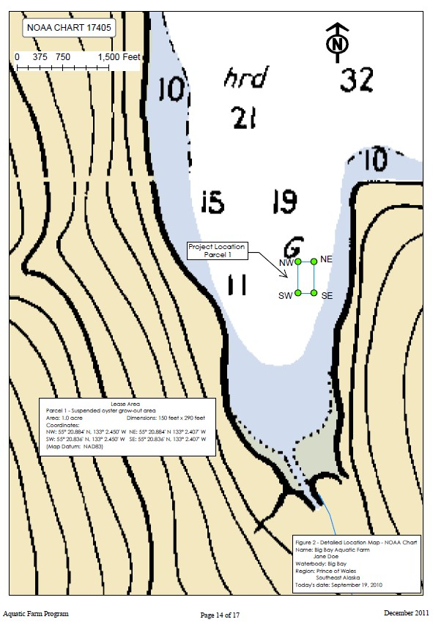

Attachment 2
Figure 3
Example Site Plan Map

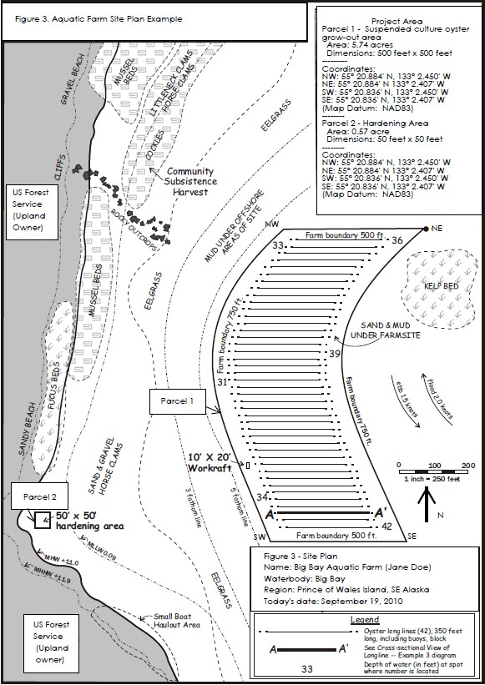
Attachment 2
Figure 4
Example Site Plan Map

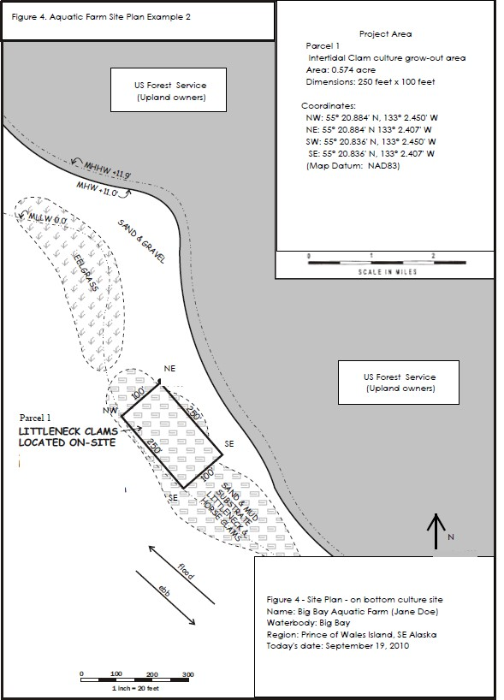
Attachment 2
Figure 5
Example Cross Sectional Diagram and Detailed Drawing
