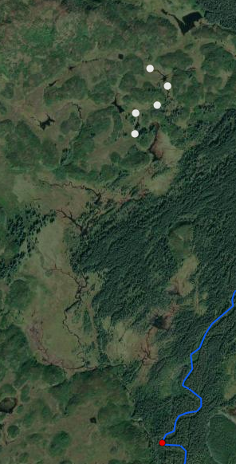

Gines Creek

Upper Extent

Lower Extent