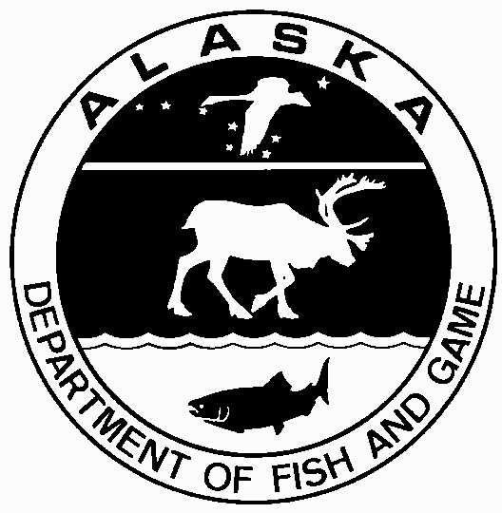
STATE OF ALASKA

DEPARTMENT OF FISH AND GAME
PROPAGATION APPLICATION
FOR
CLASSROOM INCUBATION PROJECT
AQUATIC RESOURCE PERMIT for scientific or educational purposes to take, transport, possess, hold alive, FISH AND THEIR EGGS (except gold fish and decorative tropical fish) for a CLASSROOM INCUBATION
PROJECT. The amount that can be held is less than or equal to 500 eggs or one spawning pair.

(Name of Instructor) (Organization or School)

(Mailing Address, City, State, Zip Code)

Telephone: (work) (fax) (home)

(School District) (Email)

I would like to conduct a classroom incubation project using the following species: (check the appropriate box)
chum (dog) salmon pink (humpy) salmon coho (silver) salmon Other:

I would like to incubate/rear a total of (amount requested). The maximum amounts for this permit are less than or equal to 500 eggs or one spawning pair.

Life stage requested: (check appropriate box)
Spawning adult (maximum one spawning pair)
Green eggs (newly fertilized--later summer through late fall)
Eyed eggs (eyes visible in egg--available early winter to mid winter)
Alevin (newly hatched yolk-sac fry--generally not transportable)
Emergent fry (early free swimming juvenile salmonid--available spring)

I wish to obtain the above by means of: (check appropriate box)
Directly from hatchery. Name of hatchery:

Approximate date of transport: to , 20

Remote location. Name of stream, river, or lake:

Approximate date of transport: to , 20

Method: (check appropriate box)
beach seine gillnet dip net rod and reel
other technique (please explain the procedures planned for the egg take):

Isolation measures planned to control disease during transport, including description of container, water source, and method and plan for transport:

The eggs and fish will be reared in:
recirculating aquarium flow-through aquarium
other (describe incubation and rearing system)

Source of water for rearing and proposed effluent discharge location:

Final disposition: (check appropriate box)
And approximate date of disposition: to , 20

destroyed as result of experimentation
destroyed at termination of project
released at egg-take site
released into ADF&G approved landlocked lake. Name:

Release should be timed as nearly as possible to the natural timing of the donor stock, the plankton bloom, or at a time appropriate to maximize the survival rates. The project is for educational purposes only and any adult returns from this project may not be claimed as exclusive property of the project.

The following persons will participate in the project under terms of the permit being requested:

The completed application must be submitted to the Alaska Department of Fish and Game, Division of Commercial Fisheries, Attn: Permit Coordinator, PO Box 115526, Juneau, AK 99811-5526 or dfg.fmpd.permitcoordinator@alaska.gov.

For additional information, please contact the Permit Coordinator at 907-465-4724 or email listed above.

***A WRITTEN OPERATIONAL OR STUDY PLAN IDENTIFYING THE PURPOSE AND THE NEED FOR THE CLASSROOM INCUBATION PROJECT, RESEARCH OBJECTIVES, PROCEDURES, AND AN EXPLANATION OF BENEFITS TO THE STUDENTS THAT MAY ACCRUE MUST BE ATTACHED.***

